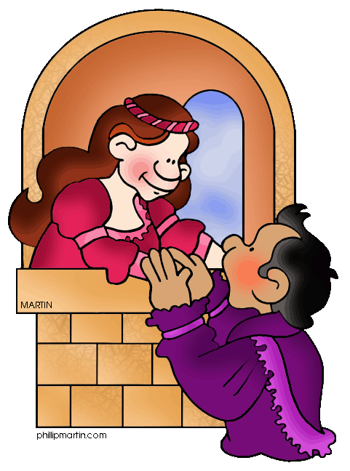
Name:_________________
Hour:_________
Romeo and Juliet: Act Two Comprehension Check
Directions: To give you a comprehensive understanding of all aspects of the play, answer the following questions using complete sentences on a separate sheet of paper. Answers can be typed if you prefer.
Prologue
- What more do we learn about the story from the Prologue in Act Two?
Scene One
- What does Romeo mean by “He jests at scars that never felt a wound”?
Scene Two
- When Romeo first sees Juliet, to what does he compare her?
- According to Romeo, who is jealous of Juliet’s beauty?
- What does Juliet want Romeo to do before she realizes he is there?
- Explain Juliet’s speech about the importance of names.
- How does Romeo claim he was able to get over the orchard walls? Why is Romeo unafraid of Juliet’s kinsmen?
- Who, according to what Romeo tells Juliet, gave him directions to Juliet’s balcony?
- How does Juliet covertly indicate that she may doubt Romeo’s love for her? Find two quotes that show Juliet is testing Romeo.
- Why does Juliet tell Romeo not to “swear by the moon”?
- Who mentions the idea of marriage first? What is your reaction to this proposal?
- Explain the line “Parting is such sweet sorrow”.
Scene Three
- What is Friar Lawrence doing at the beginning of scene three?
- Who does Friar Lawrence think Romeo has been with all night?
- What does Romeo ask Friar Lawrence to do?
- Why does Friar Lawrence question Romeo’s request?
- What is Friar Lawrence’s reason for agreeing to marry Romeo and Juliet?
Scene Four
- What news does Benvolio tell Mercutio at the beginning of scene four?
- Why does Mercutio say Romeo is already dead?
- The Montague boys think Romeo was still with Rosaline last night. Why do you think Romeo doesn’t tell them the truth?
- Who teases the Nurse, and why?
- What does Romeo want the Nurse to have Juliet do? What will then happen?
Scene Five
- How long has Juliet been waiting for the Nurse to come with word from Romeo?
- The Nurse knows Juliet has been waiting for news, yet she continues to put Juliet off. Why do you think she does this? What does this scene reveal about their relationship?
- What task does the Nurse mention she must do at the end of scene five?
Scene Six
- Of what are we reminded by Friar Lawrence’s line “These violent delights have violent ends”?
- What even may or may not happen onstage in front of the audience? If you were the director, how would you stage the end of Act Two?

