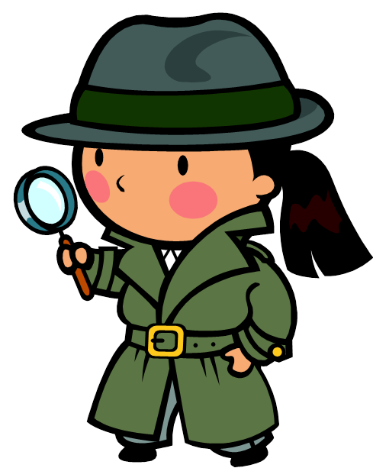
Names:____________________ and ___________________

Foreshadowing in Of Mice and Men
Now that you have finished Of Mice and Men, it is your job to look closer at foreshadowing and how John Steinbeck had been leaving clues to the ending from as early as Chapter One. Working with a partner, you will explore foreshadowing from both directions:
- Looking from the final event back on the entire book for clues that it would happen
- Looking from the first clue forward to see what events happened after it

It will require some close reading and actual examples (quotes, paraphrasing, etc.). Your examples should be specific and not just general statements. Saying “bad things happen” is not specific. Saying that “Lennie got into a fight with Curley” is specific. Happy clue hunting and good luck!

Final Event | Clue #1 | Page # | Clue #2 | Page #
Curley’s wife dies from a broken neck caused by Lennie.
Curley forms a lynch mob to kill Lennie after his wife’s death

George shoots Lennie.

First Clue | Event #1 | Page # | Event #2 | Page #
George tells Lennie to run to the river if he gets in trouble.

Lennie and George had to leave Weed because he felt a girl’s dress

Lennie says that he doesn’t like this place and
wants to leave.

George tells Lennie to stay away from Curley and Curley’s wife.

